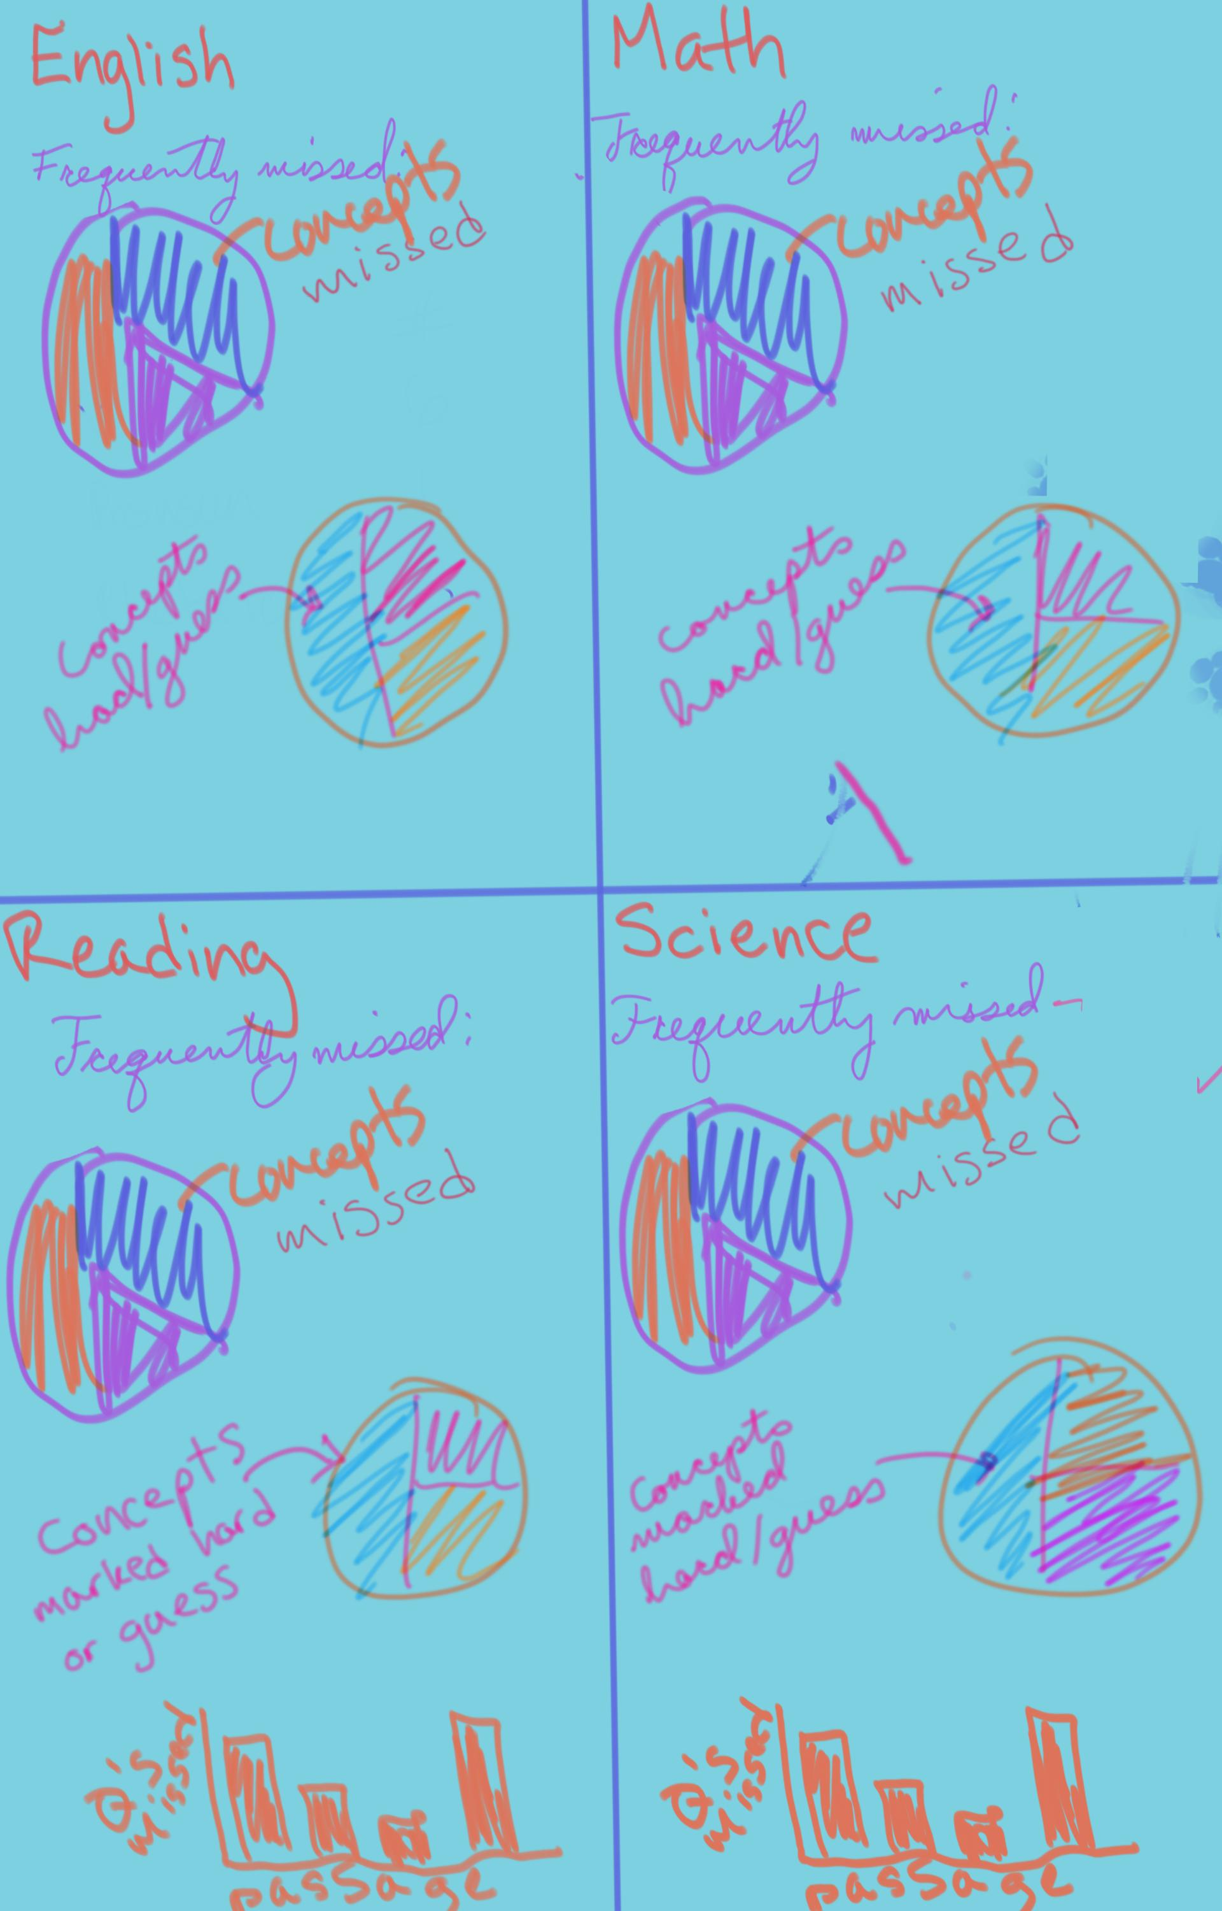Colors DO

1. Student answers questions [give developer questions including the student's name, if it is the pre-test, test after 10 hours, test after 20 hours of tutoring, etc]
2. Screen that preps student to start [indicate that test will be timed the way the test is with breaks
3. Timer starts [have option for time and a half for students with accommodations based on question page], student is able to fill in answers, need alert that shows up at end that says will keep going until finished
4. have break page telling them what to do and how long they have until next sections starts [make based on real test]
5. continue with rest of test
6. results page that is emailed to [support@cognitutor.com](mailto:support@cognitutor.com) and tutor's email [given on first page][these results are based on answers and concepts given to developer]

Colors do NOT have to be same. This is just to emphasize that it should be colorful, readable, and have a complimentary color scheme.

Pie graphs on concept sheet two should have the top five most missed concepts and then an “other” category that could possibly be clicked on to see the full results on the rest of the concepts.

Bar graphs are just for Reading and Science, can be more colorful than made up. Should say “Data representation” or “prose fiction” etc. under the passages.

If click functions are too complex to create, perhaps a text box could be inserted onto the page that displays that information (refers to both the pie graphs and the “questions marked ___”)

If needs to be the two sheets need to be one, they can be merged together with concept sheet 1 on top and concept sheet 2 below.

Time is up alert after allotted time is up, then asks if student would like to continue

|  |  |  |  |
| --- | --- | --- | --- |
| **ACT Section** | **Total Time** | **Start Time** | **End Time** |
| English | 45 mins | 8:30 am | 9:15 am |
| Math | 60 mins | 9:15 am | 10:15 am |
| *Break* | 10 mins | 10:15 am | 10:25 am |
| Reading | 35 mins | 10:25 am | 11:00 am |
| Science | 35 mins | 11:00 am | 11:35 am |
| *Break (some students leave)* | 5 mins | 11:35 am | 11:40 am |
| Writing (optional) | 40 mins | 11:40 am | 12:20 pm |

Add these to the questions before the test:

1. Do you have a learning disability? Adhd, dyslexia   or get accommodations of the test?

2. Are you normally a bad test taker, bad standardized test taker, or have test anxiety? (Maybe try one with 1.5 time accommodation?)( you can do it!!

3. List all past tests and scores

4. Do you get a 1.5 accommodation? (if click this then change website timing of test to)

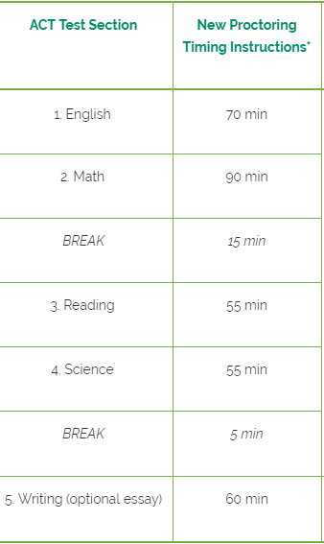

Have real test instructions typed and have this question RIGHT before they take the test along with letting them know this test will be timed and have timed breaks just like the real test and they can't pause it.

Do you have this test printed out? (If no, record their answer but tell them they need to. If yes, then tell them to:) answer on the test and then type in your answers here.

Ask these questions at the end of the assessments:

1. How did you feel you did on the test? Predict the score you think you got

2. Did you run out of time?

3. Were you anxious or feel rushed?

4. Were you able to focus?

5. Did you take too long on certain questions? You should skip) Taking too long

6. What strategies did you use for each section? What helped? What didn't?

7. Did you feel sick or did anything that could affect your score happen?

8. If you did poorly on this test, why do you think that would be?

9. Was there a lot of material on the test you didn't recognize?

10. Did tutoring help prepare you for the material on this test?

11. Did you take this test in a quiet environment without distractions? Was your environment like the real test environment?

12. What did you have more problems with on the test?

13. Any other comments?

Show these tips at the end of the last assessment:



 We suggest you take the real test at least 2 times (SAT and ACT) after tutoring

a.       Don’t cram the night before

b.      Plan something exciting to do after the test to look forward to!

c.       Don't get stuck so skip questions or go to end to just get started if you have to

d.      Don't pay attention to other people. Maybe sit in the front if that's where there will be fewer distractions

e.      Watch clock, but don't obsess over it

f.        Have a consistent test routine: sleep at the same time a few days before the test, eat the same amount and foods the way you practiced, use the same calculator, get to the test early and know where you are going beforehand

g.       You can take many more tests to get a better score so don't worry about this one!! We recommend students take at least 2 tests after tutoring (of ACT and SAT)! You will improve 🙂

h.      Visualize doing well on test day: wake up, get breakfast, snack, calculator, ticket, drive to test site, sit down take test, watch clock, take break, finish feeling good and leave.

i.         Don't talk to other students before test. They might make you nervous

j.        Expect curveballs on the test. Skip questions if you don't know them

k.       Practice using relaxation techniques during practice tests and on the real test:

                                                               i.      Close your eyes.

                                                             ii.      Breathe in slowly to the count of seven and exhale to the count of seven.

                                                            iii.      Continue this slow breathing until you actually feel your body begin to relax. (Most people find that it takes 2 to 4 sequences.)

                                                           iv.      Open your eyes and give yourself a positive, very specific self-talk (i.e., "You're sure to do well. You studied hard. You’re doing the best you can. You succeeded at...") This whole procedure should take only about a minute and it's well worth the time.